**Experiment 1.2**

**Student Name: Rahul Kumar UID: 20BCS7081**

**Branch: CSE Section/Group: 716/B**

**Semester: 6th Date of Performance: 2 March 2023**

**Subject Name: MAD Lab**

1. **Aim:**

To design an android application to display Hello World

1. **Objective:**
2. To know About the text editing in android studio.
3. Using additional features of the android studio.
4. **Script and Output:**

First step is to create a simple Android Application using Android studio. When you click on Android studio icon, it will show screen as shown below

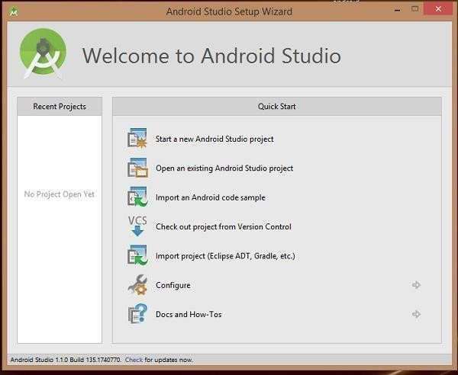

You can start your application development by calling start a new android studio project.in a new installation frame should ask Application name, package information and location of the project.−

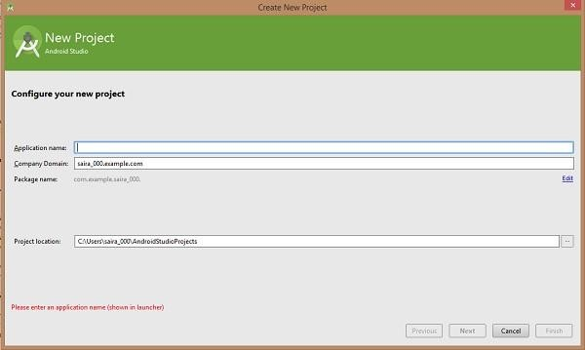

Configure the Hello World Project Details We'll finish creating the project by configuring some details about its name, location, and the API version it

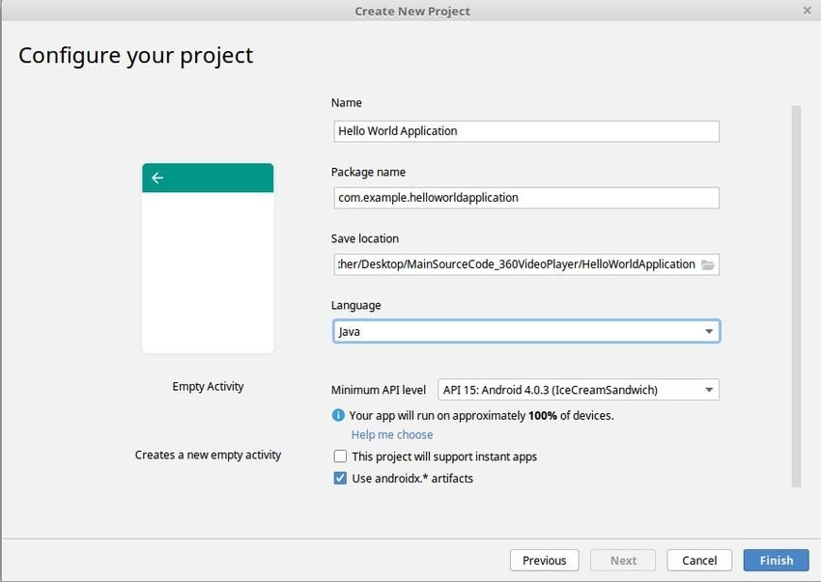

Change the name of the application. Change the default **Project location** to your preferred directory or just leave it as the default location.

On the **minimum API level**, ensure that **API 15: Android 4.0.3 Ice Cream Sandwich** is set as the Minimum SDK. This ensures that your application runs on almost all devices.

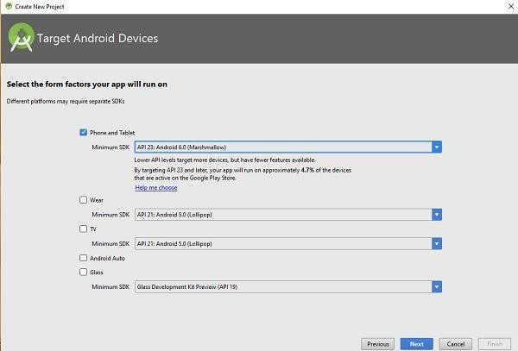

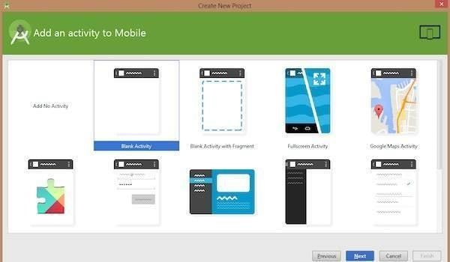Then next level of installation should contain selecting the activity to mobile, it specifies the default layout for Applications.

**Source Code –**

The Main Activity File

## The main activity code is a Java file Main Activity. java. This is the actual application file which ultimately gets converted to a Dalvik executable and runs your application

package com.example.demoapp;  
  
import androidx.appcompat.app.AppCompatActivity;  
  
import android.os.Bundle;  
  
public class MainActivity extends AppCompatActivity {  
  
 @Override  
 protected void onCreate(Bundle savedInstanceState) {  
 super.onCreate(savedInstanceState);  
 setContentView(R.layout.*activity_main*);  
 }  
}

## The Layout File –

The **activity_main.xml** is a layout file available in res/layout directory, that is referenced by your application when building its interface. You will modify this file very frequently to change the layout of your application. For your "HelloWorld!" application, this file will have following content related to default layout −

<?xml version="1.0" encoding="utf-8"?>  
  
<androidx.constraintlayout.widget.ConstraintLayout xmlns:android="http://schemas.android.com/apk/res/android"  
 xmlns:app="http://schemas.android.com/apk/res-auto"  
 xmlns:tools="http://schemas.android.com/tools"  
 android:layout_width="match_parent"  
 android:layout_height="match_parent"  
 tools:context=".MainActivity">  
  
 <TextView  
 android:id="@+id/textView"  
 android:layout_width="wrap_content"  
 android:layout_height="wrap_content"  
 android:text="hello world"  
 android:textSize="3mm"  
 tools:layout_editor_absoluteX="179dp"  
 tools:layout_editor_absoluteY="322dp" />  
</androidx.constraintlayout.widget.ConstraintLayout>

**Output –**

